“FARM OUT” Features in Advantzware

Here are a few of the many tools to assist box makers who may also do significant “purchase and resell” business:

- Estimating a “Farm Out” Cost List Matrix
The Estimating system gives you the capability of doing a corrugated cost estimate and then flagging the item as purchased. Once you indicate that the item is purchased the “FARM” tab becomes available for you to put in the quantity sensitive cost provided by each of your vendors.
Advantages:
- Quick comparison between custom manufacturing vs. buy out cost
- Multiple vendor cost quantity break matrices
- Option to include setup charges for smaller quantities
- Ability to pre-select specific vendor or cost per quantity
- Automatic best cost selection by estimated quantity and vendor matrix
- Combine buyout cost with charges for warehousing, fright, G&A and additional
manufacturing
- Prevents selection of incorrect vendor based on sheet size limits
- Order entry automatically creates finished good item with vendor cost matrices
- Order entry generates a PO for the best cost vendor for the quantity ordered

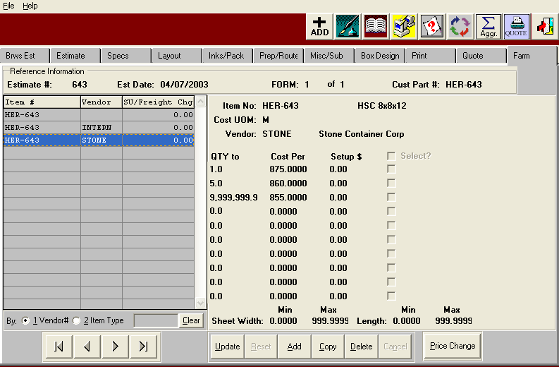

- Price List Matrix:
For items that you purchase and resell to many customers you can build Price List Matrix. A price list could be unique by item, or by type of customer or by customer. For example, the item below has unique pricing for customer ABC1000.
Advantages:
- Price lists for both purchased and manufactured items
- Price lists can be established for different customer types. e.g. a price list for sales to brokers or distributors or walk up customers
- You could also establish a discount list for a customer off from a price list
- Pricing unit of measure could be different for different customers
- Never price a stock item incorrectly (price is automatically defaulted into order entry)

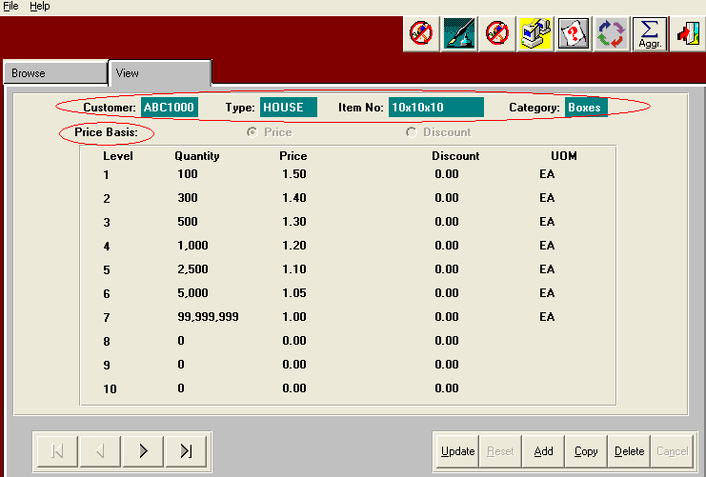

- Inventory File:
There is an inventory record for every item (manufactured or purchased). The inventory item is automatically generated for manufactured items based upon the information in the estimate. For purchased and resold items (brokered cartons, stocked boxes, bubble wrap, tapes, or any other re-sold item) an inventory record is built by the user. Let’s take a moment to review the various screens in the inventory file:

  - “View Item” tab
Basic information related to the product

Advantages:
- “Sell price” becomes the default if no quantity sensitive price list matrix is established
- Pricing unit of measure is indicated (you can price in one unit, store in another and purchase in another).
- Cycle count types can be associated with this item
- Items can be stored or drop shipped from your vendor

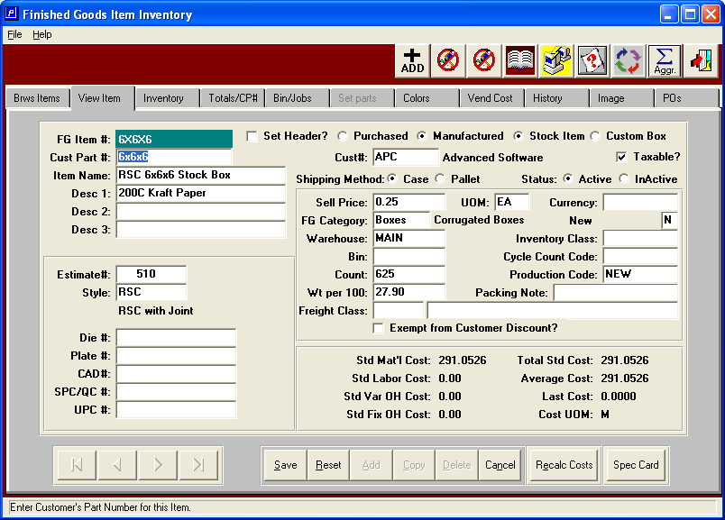

  - “Inventory Tab”
Provides information utilized for suggested reordering queries in purchasing, such as reorder levels, minimum and maximum order quantities and lead time days. The inventory counts by classification (at the bottom) shows the quantity on hand, on order, allocated, backordered and available. The buttons for on hand, on order and allocated allow you to explode to the details.

Advantages:
- Reorder advise reports are generated with suggested reorder amounts
- Lead days assist in reorder analysis
- Quick glance of inventory “bucket” totals (on-hand, allocated, on order etc.)
- Quantity balances are dynamically updated and can be viewed at any time
- Set items can be stocked at the assembled or component level

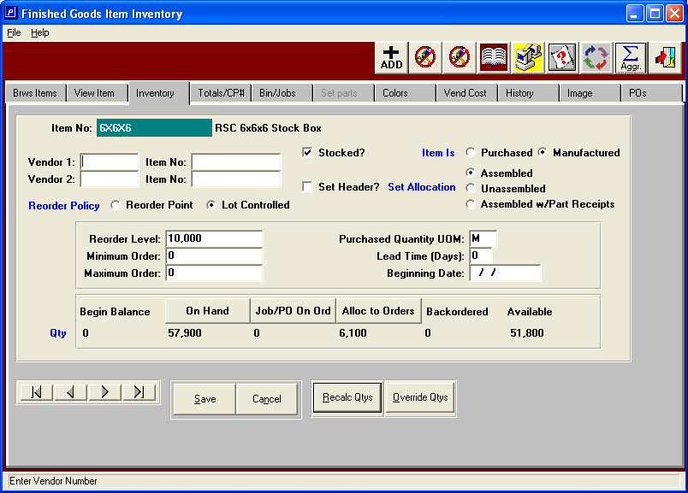

  - “Totals C/P Tab”
PTD, YTD and prior year information as yell as any unique customer part numbers

Advantages:
- You can establish unique customer part numbers for the same stock item
- This unique part number then print’s on that customer’s BOL and invoice, yet we control the stock globally.

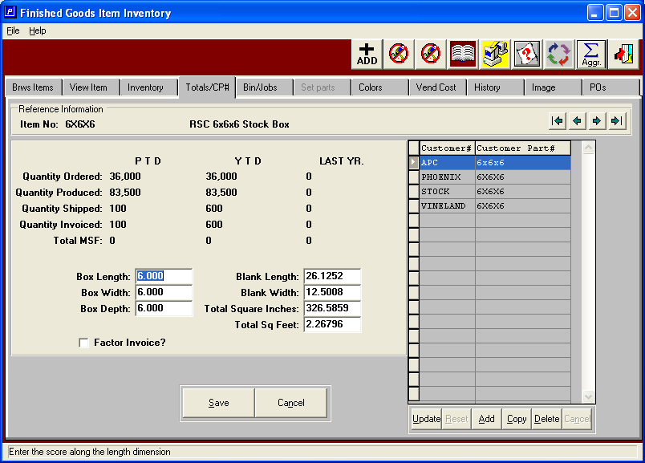

  - “Bin/Jobs Tab”
Shows the physical location of the on hand inventory (by warehouse, bin and tag number) for all items, both manufactured and purchased

Advantages:
- Immediately find the location of all stock by unit or total units & unit count
- See associated job number for manufactured items

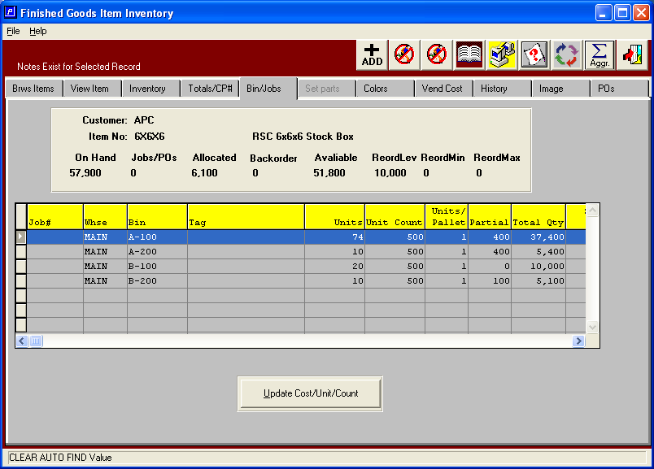

  - “Colors tab”
Printing or coating associated with this item

Advantages:
- Quickly identify any uniqueness of the item vs. a same size item in stock
- Can add print information to purchased items (manufactured information comes from the estimate)

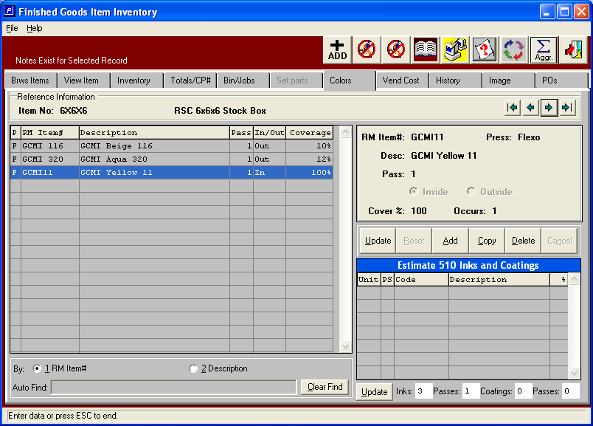

  - “Vendor Cost Tab”
Quantity sensitive cost for stock and resold items

Advantages:
- Data can be entered or is automatically created from the FARM tab of the estimate
- Multiple vendor cost quantity break matrices
- Option to include setup charges for smaller quantities
- Ability to pre-select specific vendor or cost per quantity
- Automatic best cost selection by estimated quantity and vendor matrix
- Prevents selection of incorrect vendor based on sheet size limits
- Order entry generates a PO for the best cost vendor for the quantity ordered

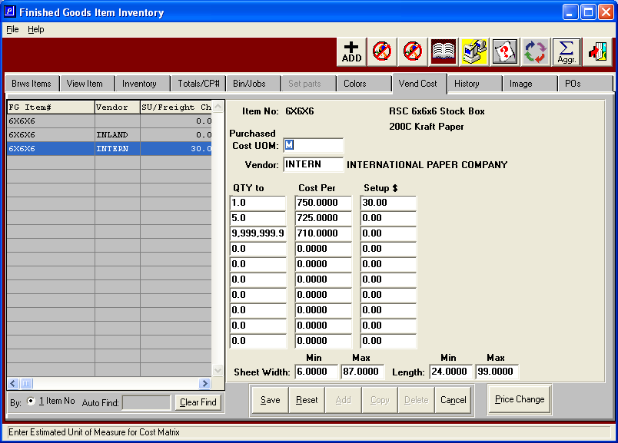

  - “History Tab”
All inventory transactions for this item

Advantages:
- See every transaction by transaction type (shipment, receipt, transfer, cycle count, physical adjustment)
- Inventory cost details by tag number
- Sort (yellow columns) by each column

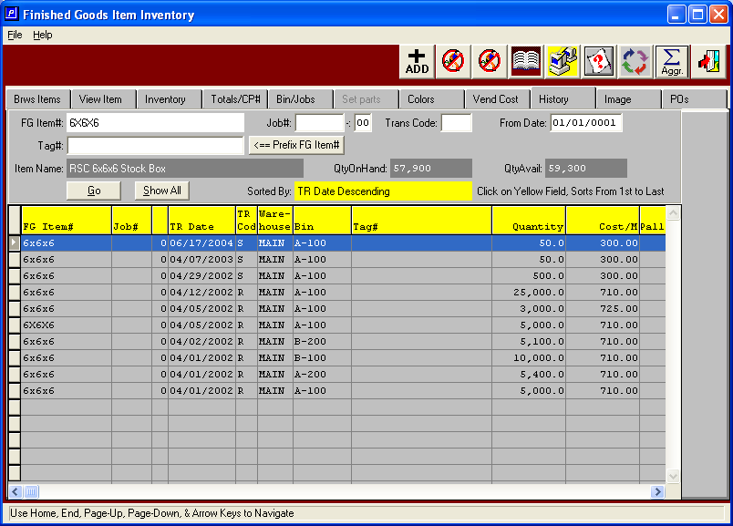

  - “Image Tab”
Can scan an image (set up, print card, cad drawing etc.) & associate with the item

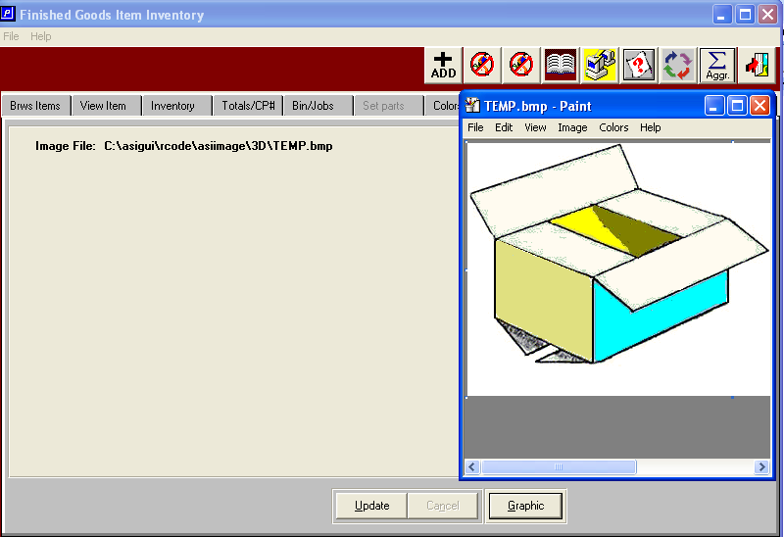

- “PO Tab”
Provides the purchasing history of the item

Advantages:
- Immediate see the status of on-order items
- Search purchase history for the item

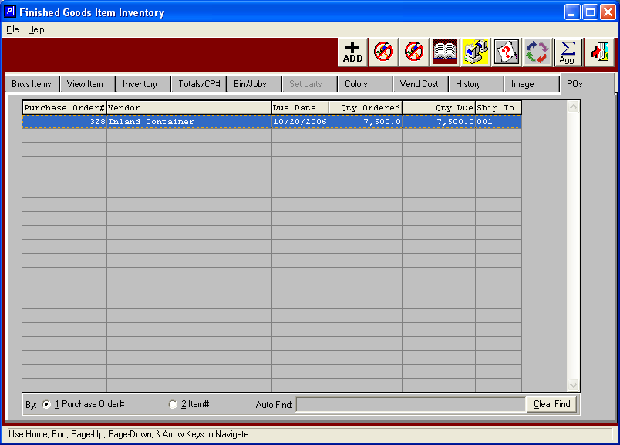

4. Order Entry – Line items:
At order entry time the user can enter an unlimited number of PO line items on the same input screen. Since the system differentiates between an “order” and a “job” a single order number and related customer’s PO number, could have any number of manufacturing jobs and any number of pull from stock jobs.

Advantages:
- Input unlimited line items at order entry for a single client PO
- Combine purchased stock with manufactured stock
- System creates multiple jobs (line items) per order
- Prices brought in from quotation history (manufactured)
- Prices brought in from inventory price list (if stocked)

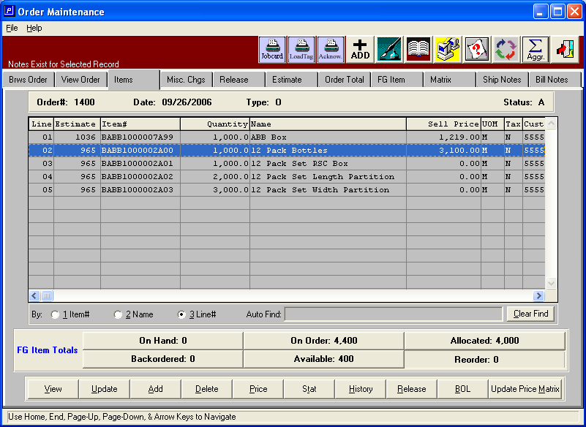

5) Order Entry – Releases:

Each job has its own release date and release type (ship and invoice, invoice only, ship only or transfer only). This provides you with the tools to manage unique needs such as consignments where you can “invoice only” after a contracted 90 day period and then “ship only” at a later date while controlling the customer’s inventory in the mean time.

Advantages:
- Release types for each job (Invoice only, ship only, both, transfer)
- Single order can be broken to multiple releases
- Single order could have multiple release quantities
- Releases can be for different dates
- Controls consignment stock
- Release to different ship to locations
- Handles planned and actual release
- Release with different ship via
- Can change PO # by release

